Compare Different Classification Algorithms and Evaluate Their Performance
Aim
To implement and compare different classification algorithms in Python and evaluate their performance using Accuracy, Confusion Matrix, and Classification Report.

Apparatus Required
- Google Colab / Jupyter Notebook
- Python 3
- Libraries:
  - NumPy
  - Pandas
  - Scikit-learn (sklearn)

Theory
Classification is a supervised machine learning technique used to predict the class label of input data. Different classification algorithms have different strengths and are suitable for different types of datasets.
The algorithms compared in this experiment are:
- Logistic Regression
- K-Nearest Neighbours (KNN)
- Decision Tree
- Naïve Bayes
The performance of each classifier is evaluated using:
- Accuracy Score
- Confusion Matrix
- Classification Report

Algorithm
- Import the required libraries.
- Load the Iris dataset.
- Split the dataset into training and testing sets.
- Train Logistic Regression, KNN, Decision Tree, and Naïve Bayes models.
- Predict the test data using each model.
- Calculate Accuracy for each model.
- Compare the performance of all classifiers.

Code (Google Colab)
from sklearn.datasets import load_iris
from sklearn.model_selection import train_test_split
from sklearn.preprocessing import StandardScaler
from sklearn.linear_model import LogisticRegression
from sklearn.neighbors import KNeighborsClassifier
from sklearn.tree import DecisionTreeClassifier
from sklearn.naive_bayes import GaussianNB
from sklearn.metrics import accuracy_score, confusion_matrix, classification_report

# Load Iris Dataset
iris = load_iris()
X = iris.data
y = iris.target

# Split Dataset
X_train, X_test, y_train, y_test = train_test_split(
X, y, test_size=0.3, random_state=42
)

# Feature Scaling
scaler = StandardScaler()
X_train = scaler.fit_transform(X_train)
X_test = scaler.transform(X_test)

# Models
models = {
"Logistic Regression": LogisticRegression(max_iter=200),
"KNN": KNeighborsClassifier(n_neighbors=3),
"Decision Tree": DecisionTreeClassifier(random_state=42),
"Naive Bayes": GaussianNB()
}

# Train and Evaluate
for name, model in models.items():
model.fit(X_train, y_train)
y_pred = model.predict(X_test)

print("=" * 50)
print(name)
print("=" * 50)
print("Accuracy:", accuracy_score(y_test, y_pred))
print("\nConfusion Matrix:")
print(confusion_matrix(y_test, y_pred))
print("\nClassification Report:")
print(classification_report(y_test, y_pred))
print()

Sample Output
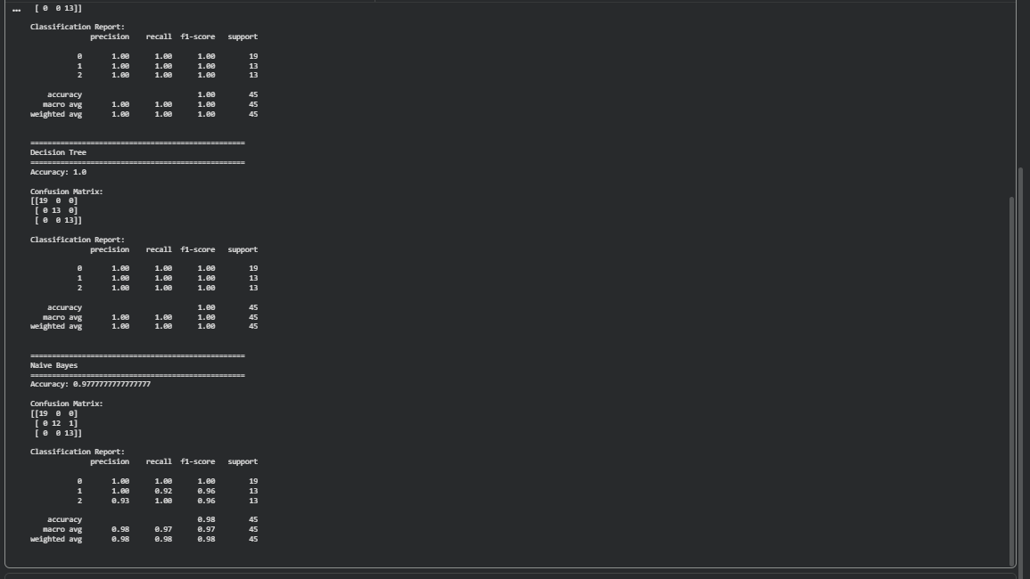
Result
The different classification algorithms (Logistic Regression, K-Nearest Neighbours, Decision Tree, and Naïve Bayes) were successfully implemented and compared using the Iris dataset. Their performance was evaluated using Accuracy, Confusion Matrix, and Classification Report. The comparison showed that all classifiers achieved high accuracy on the Iris dataset, demonstrating their effectiveness for this classification task.

